Parts of a Seed – Teacher Guide

Name: _________________ Date: ________

There are two kinds of plants. There are plants that have one leaf in the seed, and plants with two leaves in the seed. These first leaves on a plant are called **cotyledons**.

Plants that start with one leaf are called **monocots**.

Plants that start with two leaves are called **dicots**.

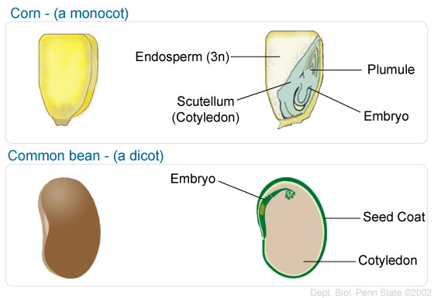

1. What Iowa crop is a monocot? _**corn**______
2. What Iowa crop is a dicot? ____**soybean**___
3. Compare and contrast the two seeds.

The cotyledons are larger in dicots, endosperm is present in monocot, both contain embryos, etc.

1. Label and color these pictures.

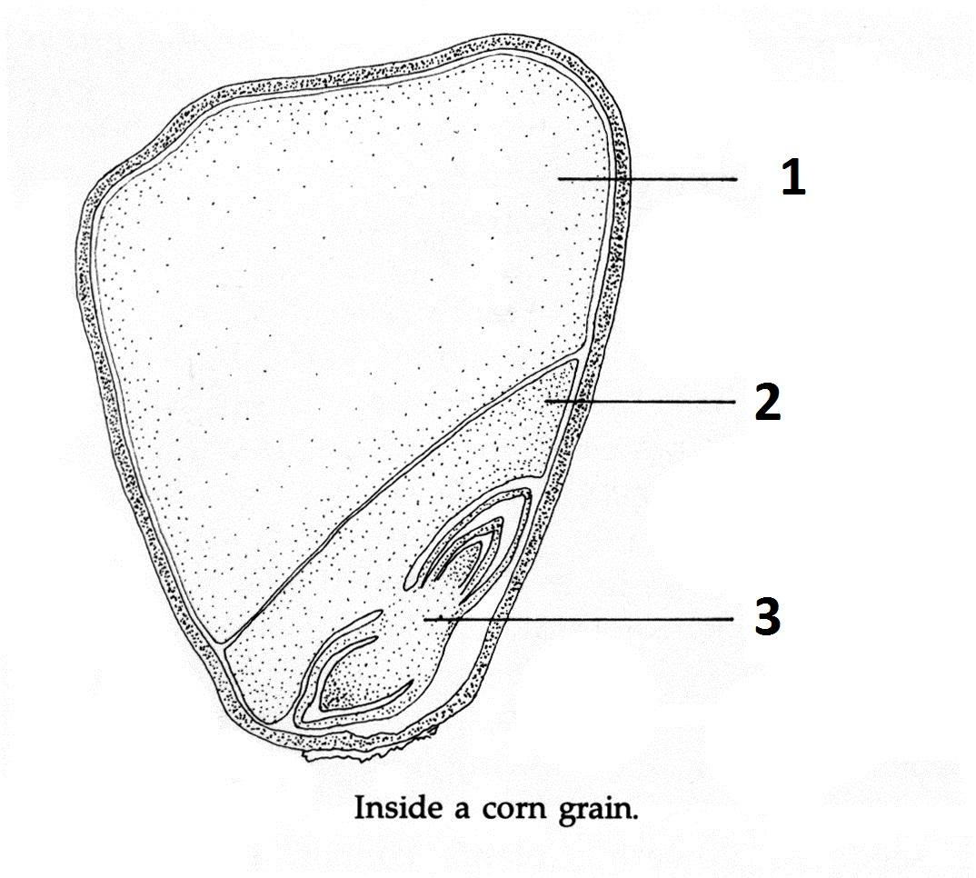

Cotyledon

Embryo

Endosperm

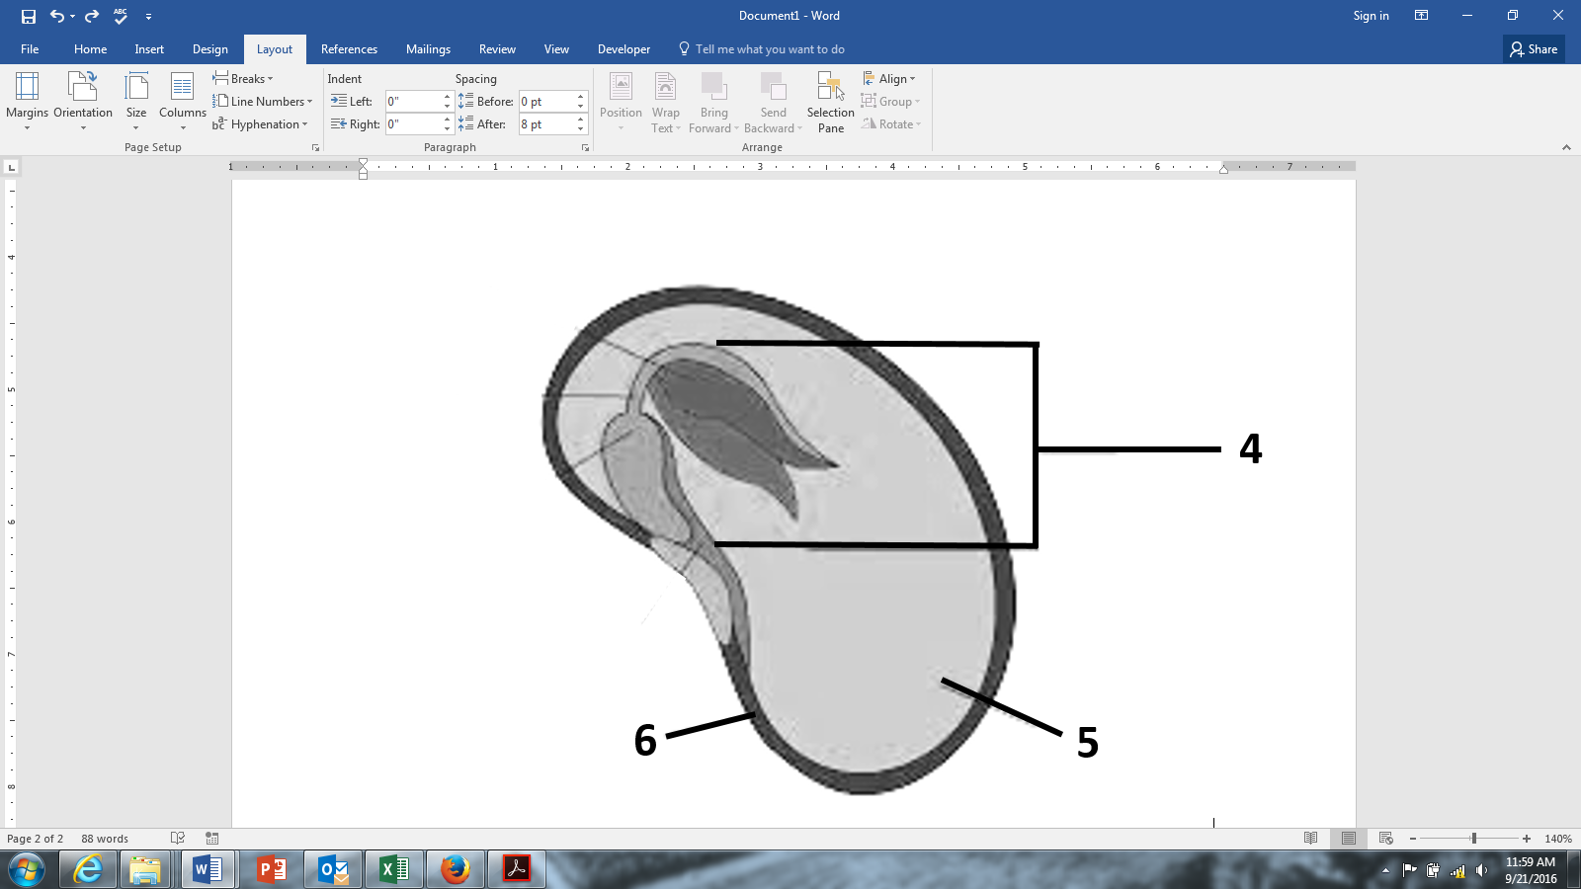

Seed coat

Cotyledons

Embryo

1. Look at your own seeds. What parts can you see? Draw your seeds and label what you can find.

This will give students the chance to look at real seeds. If they cannot see all of the parts, that is okay. If they see more than their charts show, that is okay, too.